LABORATORIO VPN 3
Redes II, Tecnicatura en Administración de Sistemas y Software Libre

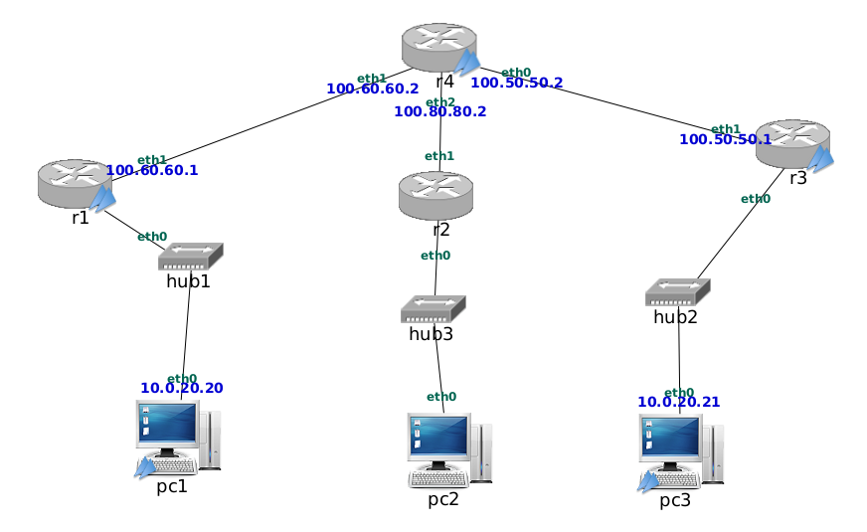

pc1:~# ping -c 3 pc3
PING pc3 (10.0.20.21) 56(84) bytes of data.
From pc1 (10.0.20.20) icmp_seq=1 Destination Host Unreachable
From pc1 (10.0.20.20) icmp_seq=2 Destination Host Unreachable
From pc1 (10.0.20.20) icmp_seq=3 Destination Host Unreachable

--- pc3 ping statistics ---
3 packets transmitted, 0 received, +3 errors, 100% packet loss, time 2008ms
, pipe 3
pc1:~#
pc3:~# ping -c 3 pc1
PING pc1 (10.0.20.20) 56(84) bytes of data.
From pc3 (10.0.20.21) icmp_seq=1 Destination Host Unreachable
From pc3 (10.0.20.21) icmp_seq=2 Destination Host Unreachable
From pc3 (10.0.20.21) icmp_seq=3 Destination Host Unreachable

--- pc1 ping statistics ---
3 packets transmitted, 0 received, +3 errors, 100% packet loss, time 2005ms
, pipe 3
pc3:~#

r1:~# ifconfig
br0 Link encap:Ethernet HWaddr 00:ff:bd:d3:5c:f5
inet addr:10.0.20.1 Bcast:10.0.20.255 Mask:255.255.255.0
inet6 addr: fe80::2ff:bdff:fed3:5cf5/64 Scope:Link
UP BROADCAST RUNNING MULTICAST MTU:1500 Metric:1
RX packets:7 errors:0 dropped:0 overruns:0 frame:0
TX packets:6 errors:0 dropped:0 overruns:0 carrier:0
collisions:0 txqueuelen:0
RX bytes:196 (196.0 B) TX bytes:468 (468.0 B)

eth0 Link encap:Ethernet HWaddr 7e:c3:c2:2c:40:aa
inet6 addr: fe80::7cc3:c2ff:fe2c:40aa/64 Scope:Link
UP BROADCAST RUNNING PROMISC MULTICAST MTU:1500 Metric:1
RX packets:20 errors:0 dropped:0 overruns:0 frame:0
TX packets:14 errors:0 dropped:0 overruns:0 carrier:0
collisions:0 txqueuelen:1000
RX bytes:1112 (1.0 KiB) TX bytes:1140 (1.1 KiB)
Interrupt:5

eth1 Link encap:Ethernet HWaddr aa:bb:cc:00:01:06
inet addr:100.60.60.1 Bcast:100.60.60.255 Mask:255.255.255.0
inet6 addr: fe80::9403:e6ff:fe78:2611/64 Scope:Link
UP BROADCAST RUNNING MULTICAST MTU:1500 Metric:1
RX packets:155 errors:0 dropped:0 overruns:0 frame:0
TX packets:157 errors:0 dropped:0 overruns:0 carrier:0
collisions:0 txqueuelen:1000
RX bytes:14255 (13.9 KiB) TX bytes:14589 (14.2 KiB)
Interrupt:5

lo Link encap:Local Loopback
inet addr:127.0.0.1 Mask:255.0.0.0
inet6 addr: ::1/128 Scope:Host
UP LOOPBACK RUNNING MTU:16436 Metric:1
RX packets:2 errors:0 dropped:0 overruns:0 frame:0
TX packets:2 errors:0 dropped:0 overruns:0 carrier:0
collisions:0 txqueuelen:0
RX bytes:100 (100.0 B) TX bytes:100 (100.0 B)

tap0 Link encap:Ethernet HWaddr 00:ff:bd:d3:5c:f5
inet6 addr: fe80::2ff:bdff:fed3:5cf5/64 Scope:Link
UP BROADCAST RUNNING PROMISC MULTICAST MTU:1500 Metric:1
RX packets:8 errors:0 dropped:0 overruns:0 frame:0
TX packets:8 errors:0 dropped:12 overruns:0 carrier:0
collisions:0 txqueuelen:100
RX bytes:672 (672.0 B) TX bytes:672 (672.0 B)

r1:~#
r3:~# ifconfig
br0 Link encap:Ethernet HWaddr 00:ff:4b:b8:66:f5
inet addr:10.0.20.2 Bcast:10.0.20.255 Mask:255.255.255.0
inet6 addr: fe80::2ff:4bff:feb8:66f5/64 Scope:Link
UP BROADCAST RUNNING MULTICAST MTU:1500 Metric:1
RX packets:0 errors:0 dropped:0 overruns:0 frame:0
TX packets:5 errors:0 dropped:0 overruns:0 carrier:0
collisions:0 txqueuelen:0
RX bytes:0 (0.0 B) TX bytes:398 (398.0 B)

eth0 Link encap:Ethernet HWaddr 5e:a9:2d:89:71:04
inet6 addr: fe80::5ca9:2dff:fe89:7104/64 Scope:Link
UP BROADCAST RUNNING PROMISC MULTICAST MTU:1500 Metric:1
RX packets:0 errors:0 dropped:0 overruns:0 frame:0
TX packets:4 errors:0 dropped:0 overruns:0 carrier:0
collisions:0 txqueuelen:1000
RX bytes:0 (0.0 B) TX bytes:308 (308.0 B)
Interrupt:5

eth1 Link encap:Ethernet HWaddr aa:bb:cc:00:01:11
inet addr:100.50.50.1 Bcast:100.50.50.255 Mask:255.255.255.0
inet6 addr: fe80::ac7e:78ff:fe19:e912/64 Scope:Link
UP BROADCAST RUNNING MULTICAST MTU:1500 Metric:1
RX packets:0 errors:0 dropped:0 overruns:0 frame:0
TX packets:4 errors:0 dropped:0 overruns:0 carrier:0
collisions:0 txqueuelen:1000
RX bytes:0 (0.0 B) TX bytes:308 (308.0 B)
Interrupt:5

lo Link encap:Local Loopback
inet addr:127.0.0.1 Mask:255.0.0.0
inet6 addr: ::1/128 Scope:Host
UP LOOPBACK RUNNING MTU:16436 Metric:1
RX packets:2 errors:0 dropped:0 overruns:0 frame:0
TX packets:2 errors:0 dropped:0 overruns:0 carrier:0
collisions:0 txqueuelen:0
RX bytes:100 (100.0 B) TX bytes:100 (100.0 B)

tap0 Link encap:Ethernet HWaddr 00:ff:4b:b8:66:f5
inet6 addr: fe80::2ff:4bff:feb8:66f5/64 Scope:Link
UP BROADCAST RUNNING PROMISC MULTICAST MTU:1500 Metric:1
RX packets:0 errors:0 dropped:0 overruns:0 frame:0
TX packets:0 errors:0 dropped:5 overruns:0 carrier:0
collisions:0 txqueuelen:100
RX bytes:0 (0.0 B) TX bytes:0 (0.0 B)

r3:~#
En el caso de r1 y r2 tenemos las interfaces tap0 y br0. Investigando br0 seria un puente que usa alguna de las interfaces de red definidas, y tap0 es una interfaz virtual que usa openvpn para pasar trafico a los clientes.
Tap0 es como en el caso de los anteriores labs la interfaz usada punto a punto por los clientes vpn. Br0 actua en nivel 2 conectado a los clientes vpn (tap0) a los clientes fisicos que estan en la misma red ethernet (podemos tener conetados equipos fisicos del lado del servidor).

r1:~# ifconfig
br0 Link encap:Ethernet HWaddr 00:ff:74:e6:ab:6f
inet addr:10.0.20.1 Bcast:10.0.20.255 Mask:255.255.255.0
inet6 addr: fe80::2ff:74ff:fee6:ab6f/64 Scope:Link
UP BROADCAST RUNNING MULTICAST MTU:1500 Metric:1
RX packets:0 errors:0 dropped:0 overruns:0 frame:0
TX packets:6 errors:0 dropped:0 overruns:0 carrier:0
collisions:0 txqueuelen:0
RX bytes:0 (0.0 B) TX bytes:468 (468.0 B)

eth0 Link encap:Ethernet HWaddr da:21:91:d8:3a:df
inet6 addr: fe80::d821:91ff:fed8:3adf/64 Scope:Link
UP BROADCAST RUNNING PROMISC MULTICAST MTU:1500 Metric:1
RX packets:0 errors:0 dropped:0 overruns:0 frame:0
TX packets:6 errors:0 dropped:0 overruns:0 carrier:0
collisions:0 txqueuelen:1000
RX bytes:0 (0.0 B) TX bytes:468 (468.0 B)
Interrupt:5

eth1 Link encap:Ethernet HWaddr aa:bb:cc:00:01:06
inet addr:100.60.60.1 Bcast:100.60.60.255 Mask:255.255.255.0
inet6 addr: fe80::d4cd:deff:fed6:5f4d/64 Scope:Link
UP BROADCAST RUNNING MULTICAST MTU:1500 Metric:1
RX packets:9 errors:0 dropped:0 overruns:0 frame:0
TX packets:9 errors:0 dropped:0 overruns:0 carrier:0
collisions:0 txqueuelen:1000
RX bytes:552 (552.0 B) TX bytes:622 (622.0 B)
Interrupt:5

lo Link encap:Local Loopback
inet addr:127.0.0.1 Mask:255.0.0.0
inet6 addr: ::1/128 Scope:Host
UP LOOPBACK RUNNING MTU:16436 Metric:1
RX packets:2 errors:0 dropped:0 overruns:0 frame:0
TX packets:2 errors:0 dropped:0 overruns:0 carrier:0
collisions:0 txqueuelen:0
RX bytes:100 (100.0 B) TX bytes:100 (100.0 B)

tap0 Link encap:Ethernet HWaddr 00:ff:74:e6:ab:6f
inet6 addr: fe80::2ff:74ff:fee6:ab6f/64 Scope:Link
UP BROADCAST RUNNING PROMISC MULTICAST MTU:1500 Metric:1
RX packets:0 errors:0 dropped:0 overruns:0 frame:0
TX packets:0 errors:0 dropped:6 overruns:0 carrier:0
collisions:0 txqueuelen:100
RX bytes:0 (0.0 B) TX bytes:0 (0.0 B)

r1:~#

